Ionic and Covalent Bonds
Essential Question: How is ionic bonding different from covalent bonding?

Properties of Covalent Compounds
- Form molecules - Gases, liquids, or solids
- Atoms share localised electrons to form bonds.
- Between non-metals.
- Low melting and boiling points (unless large)
- Poor electrical conductors in all phases
- Many soluble in non-polar liquids but not in water

Properties of Ionic Compounds
- Crystalline solids (made of ions)
- Electron transfer from metal atom to non-metal atom.
- Between metals and non-metals.
- High melting and boiling points
- Conduct electricity when melted
- Many soluble in water but not in non-polar liquid

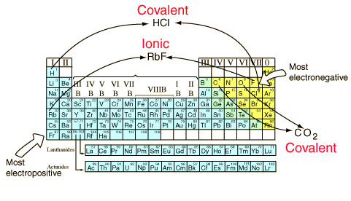
Clarifying Questions:
- Why do solid covalent compounds (molecules) have low melting points?
___________________________________________________ ___________________________________________________ ___________________________________________________
- Why do ionic compounds have high melting points?
___________________________________________________________________________________ ________________________________________________________________________________
- How does the bonding in carbon tetrachloride and sodium chloride different from each other?
_____________________________________________________________________________
_____________________________________________________________________________

Instructions: Classify the following properties as either Ionic or Covalent compounds.

_____________ 4. Atoms share electrons to become stable.
_____________ 5. High melting and boiling points
_____________ 6. Conduct electricity when melted
_____________ 7. Usually occurs between non-metals.
_____________ 8. Poor electrical conductors in all phases
_____________ 9. Many soluble in non-polar liquids but not in water
_____________10. Crystalline solids (made of ions)
_____________11. Metal atoms give electrons while non-metal atoms get electrons to become stable
_____________12. Usually occurs between metals and non-metals.
_____________13. Hydrogen and another non-metal chemically combines through covalent bonding.
_____________14. Low melting and boiling points
_____________15. Many soluble in water but not in non-polar liquid

Classify the following as metal or non-metal and ionic or covalent compounds.
Compound | First element/atom (metal or non –metal ) | Second element/atom (metal or non –metal ) | Ionic or Covalent
CH₄ | C is a non metal | H is non-metallic. | covalent
MgCl₂
H₂O
CCl₄
HF | H in this case is metallic
HCl
NaCl
Mg₃P

